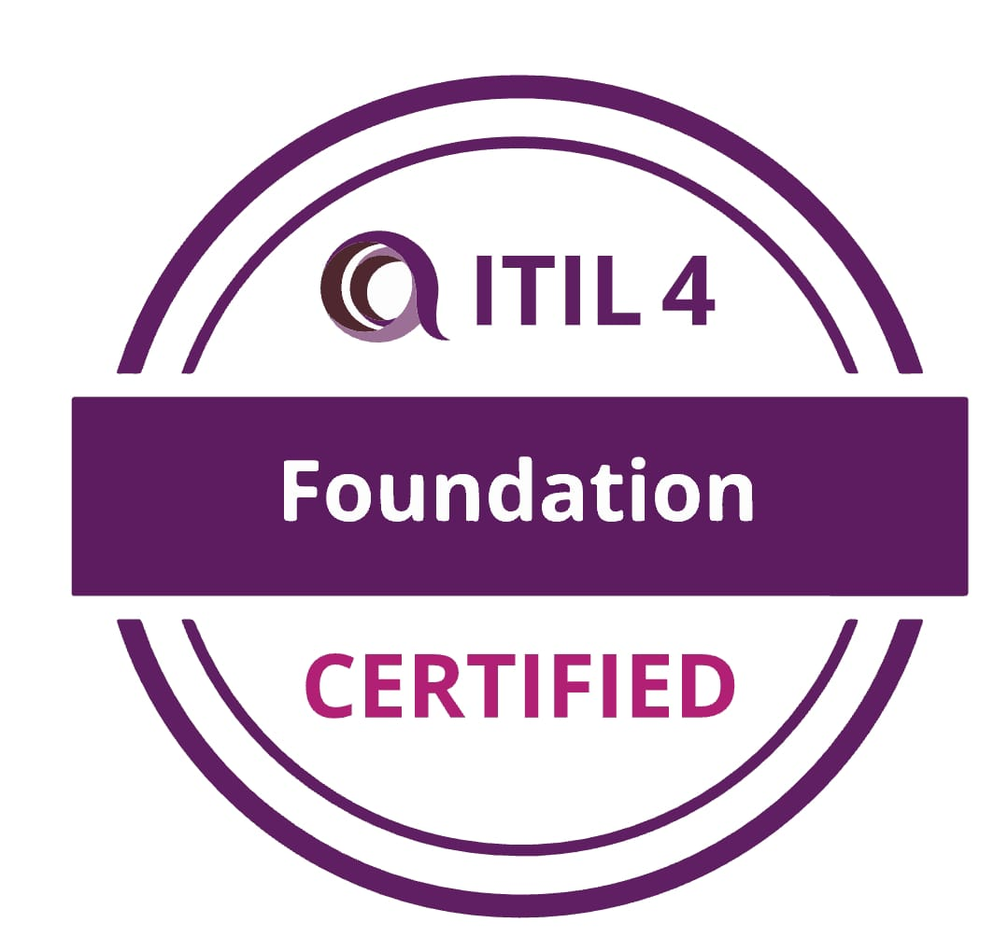
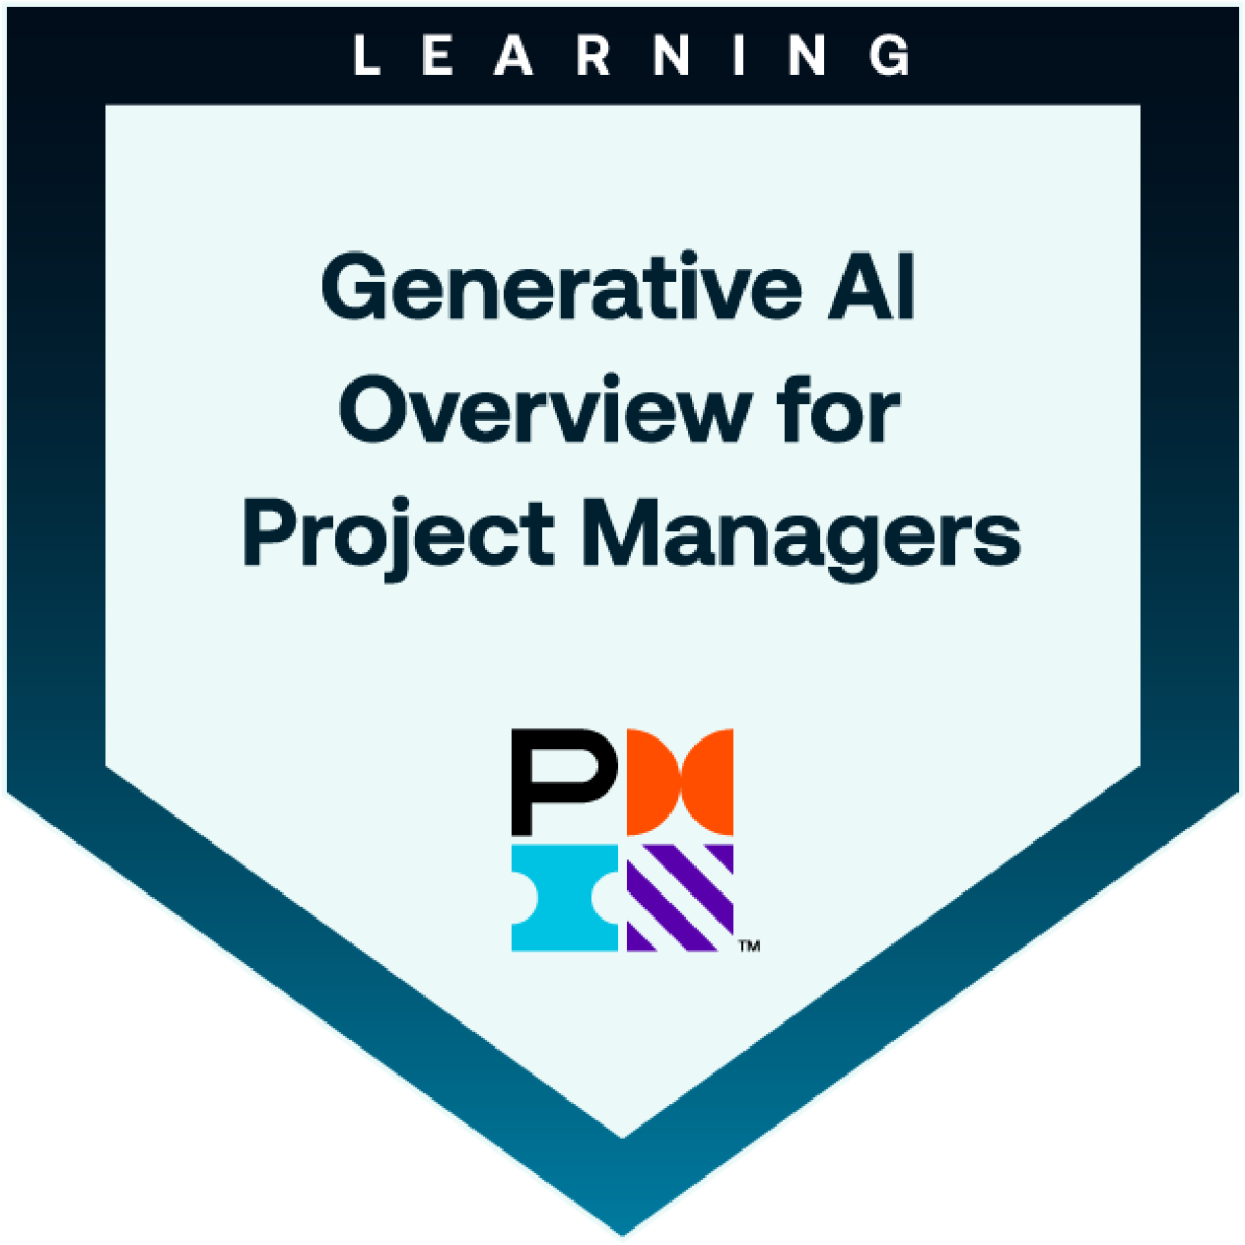
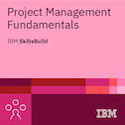
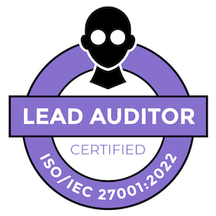
RAM KUMAR (15 Years Exp)
Project Manager-IT Infra
(Execution, Operations & Services)
V.P.O-Uchana (Lake), Dist: Karnal, Haryana; Pin: 132001
Contact: +91 – 9034263476, Email: tjt.rana@gmail.com

PROFILE SUMMARY

- 15 + Years Experiences in IT infrastructure (Execution, Operations & Services) Projects. Handling State Data Center – NOC & SOC Operations (24x7), 4 Edge/Container Data center Project Managements and IT Video Security Surveillance-Integrated Command & Control Centre (ICCC).
- Accountable for managing State Data Center NOC, SOC, and Non-IT operations (24*7) and implementation, delivering IT infrastructure support for 200 hosted Web site applications across 100+ clients.
- Responsibility for project management domains: Initiating, planning, executing, controlling and closing managing scope, cost, schedule, and contractual deliverable, which includes applying techniques for planning, tracking, change control, and risk management, Procurement management
- Leading a team of 38 members, covering Help Desk, Network Security, System & Cloud, Database, Backup, EMS, SOC, and Non-IT Data Center functions.
- Responsible for Establishment of new Tier 3 Data center according to guideline of TIA942, Uptime institute, State Data Centre, Handle Cross-functions Teams (Construction, MEP, IBMS, Cooling -InRow, IT Infra, Power) Manage IT Service and Cloud Manage Services.
- Responsible for end-to-end implementation of IT Infrastructure projects right from user requirements gathering, sponsor approval, building the project management plan, project team building, resource allocation, execution and project deliver.
- IT Infrastructure Edge Data Centre or Modular Data center or Container Data center, blue print implementations or green field infrastructure and Brown field infrastructure related projects.
- Responsible for significant, institute-wide projects, typically with large budgets and sizeable team size, focused on meeting project commitments, including communications with sponsors stakeholders etc.
- Defining the project charters, developing scope of work, building WBS, carrying out risk analysis and mitigation measures for large and complex projects. Manage forecast resource requirements that includes human, infrastructure, CapEx, OpEx etc. essential to successfully deliver a project
- Manage all project resources and establish an effective communication plan with the project team, OEM, stakeholders and the customer and provide day to day direction to the project team and regular project status to the customer.
- Proactively escalate and resolve any project-level risk and track-level Risks, Assumptions, Issues and Dependencies raised across project tracks.
- Data Center Move / Migration and Remote IT infrastructure (assessments, migration-on premise to Cloud, Cloud to cloud, Azure and AWS , consolidations, virtualization projects)
- Practical knowledge of Data Center / Disaster Recover/ Business continuity(DC/DR/BCP) planning and Execution , DR Risk Management
- Managed DCIM (Data center infrastructure Management), IBMS, EMS or NMS Infrastructure Operations, Network Operations, Service Desk, Infrastructure Planning, Network Planning.
- Oversee all aspects of projects. Set deadlines, assign responsibilities and monitor and summarize progress of project. Prepare reports for upper management regarding status of project.
- Knowledge of Cloud services delivery strategies and experience with implementations of all types of Cloud Deployment models Public, Private and Hybrid, Migration projects (AWS, GCP, Azure)
- Create a positive customer support experience and build strong relationships through communication, problem understanding and timely resolutions. Escalate/assign incidents and service requests to the development and support team as required
- Daily monitoring of Service Level Targets to meet the committed SLA; SLA Management: Ensuring SLA is met as agreed with client.
- Ensuring the weekly, monthly and quarterly reviews are in place Periodic review with Operations / Functional users / SPOC to know the pulse of IT operation and sharing the health with Client.


PROJECT MANAGER-IT INFRASTRUCTURE
Since July ’23
PLANCKDOT PVT LTD /ORBIT TECHSOL PVT LTD

Project Manager  Services Delivery Manager  IT Infra Operations & Services- state data center) IT infrastructure  ITDA-Information Technology Development Agency
- IT PROJECT OPERATIONS & SERVICES

- Responsible for managing the State Data center- UKSDC (ITDA-Information Technology Development Agency) in accordance with state government SOP guidelines, overseeing the hosting of 200 website applications for 100+ clients.
- Ensure timely delivery of implementations and ongoing services, meeting client requirements by maintaining strict control over project schedules, risks, scope, and budget.
- Support internal service review meetings that focus on performance, service improvements, quality aspects, and processes.
- Accountable for delivering excellence across all service delivery functions within an ITIL-based framework.
- Oversee security management and execute risk management processes for technical service operations, in line with SOP policies.
- Monitor and manage tickets, incidents, changes, problems, SLAs, KPIs, and requests to ensure timely resolution.
- Maintain an escalation matrix to streamline processes and minimize client operational impact.
- Ensure compliance with security policies and protocols to protect client data and systems.
- Handle NOC & SOC operations, providing VMs for security audits (VAPT/EP) in staging and production environments, managing VPN Fortinet clients, PAM access, NAC, MFA, DLP, HIPS,NIPS, APT(DDAN), Trend Micro Deep Discover security(DDI,DSM,DDAN), ArC SIEM, EMS, EDR, XDR,Netscout, Checkpoint firewall, L2/L3 network switches, Nutanix HCI, VMware HCI, compute, storage, network, and other security devices.

- IT PROJECT EXECUTION

- Managed the 4 Modular Data Centers / Container Data Centers / Edge Data Centers Execution, Operations and Services.
- Accountable for guiding and supervising the planning, implementation, and successful conclusion of data center relocation or migration initiatives. This involves collaborating with diverse teams, vendors, and stakeholders to guarantee minimal disruption to IT services throughout the transition.
- New Site Setup for Data Center Infrastructure (Constriction, MEP, IT Infrastructure, Procurement) Develop and Maintain.
- Coordinate Internal Resources and vendors for the flawless execution of Projects
- Work with Cross functional teams to effectively track project deliverables
- Lead and manage network and data center infrastructure projects from initiation to completion, ensuring adherence to timelines, budgets, and quality standards.
- Collaborate with cross-functional teams, including network engineers, system administrators, and vendors, to define project requirements, scope, and objectives.
- Manage project plans, schedules, and budgets, tracking progress against milestones and deliverables.
- Coordinate with OEMs for new tools implementations in Data center and conduct POCs for Cloud WAF, MFA, SOAR, and ZTNA.
- Coordinate with OEMs, vendors, stakeholders, and clients to ensure smooth project execution.
- Provide daily, weekly, monthly, and quarterly project reports to clients.
TECHNICAL SKILL
Data Center Infrastructure | Nutanix HCI (30 units), HP Apollo VMware HCI - Orchestration and Automation (15 units), Juniper Switches, NAC, DDAN (API), DDOS Array, WAF Array, Fortinet VPN Firewall, Checkpoint Firewall, LLB, SLB, NIPS Tipping Point, AMD (Anti-Malware Detection)
Tools | EMS (Enterprise Management Service) by MicroFocus OpenText, ESM (Endpoint Security Management), Netscout, ArC SIEM, SOAR, PAM, NAC, ZTNA, VPN, DSM, EDR, XDR, HIPS, CommVault, DLP, Honeypot, HSM, Email and Web Forcepoint
Windows Servers & Databases | Windows Server 2016, 2019, 2022; Linux Alma 9, Red Hat, MongoDB, MySQL, MS SQL, PostgreSQL, CentOS, Ubuntu

PROJECT MANAGER-IT INFRASTRUCTURE
Nov ’22 to Jun’23
TECHINFY SOLUTIONS PVT LTD

Project Manager  Services Delivery Manager  IT Infra Operations & Services- Datacenter-NMC (DC & DR) IT infrastructure   New Project Execution -NR / Datacenter establishment   Training  Video Surveillance System (VSS)
- IT PROJECT EXECUTION , OPERATIONS & SERVICES

- Responsible for the technology solutions and IT infrastructure delivery for the assigned Projects / assignment (Project Planning, Project scheduling, team coordination, Vendor Management, Resource management, stakeholder management, Risk management and project handover management)
- Manage the day-to-day project activities and resources and chairs the project management team meetings.
- Supply, Installation, Testing, Commissioning, Integration with Existing VSS Infra, IT Operation and Maintenance of IP based Video Surveillance System (VSS) at Northern Railway (RailTel) (151 Stations).
- Manage the Data Center-ICCC (DC & DR) IT Infrastructure & Security Surveillance- Operations and Services Delivery at NMC.
- Manage project scope (Planning), project schedule and project costs(budgets) define along with Governance, a communications plan, meetings, and reporting using appropriate verification techniques.
- Manage the relationship with the client and all stakeholders.
- IT projects Tracks the execution of project deliverables on a daily basis and participates in requirements gathering.
- Creating and maintaining standard project management artefacts such as project plan, risks & issues register, dependency log, progress reports etc.
- Responsible for end-to-end project management for the assigned project - includes project planning, delivery, client interaction, trouble shooting, managing project operational parameters and people management.
- Projects often involve IT-Infra & Application i.e Server, Storage, Network, Firewall ,Security, Surveillance, CCTV, Software implementation and upgrades, and Data Centre Infrastructure management.
- Identify project staffing requirements, drive staffing across various technology tracks and coordinate with all stakeholders/project teams to drive delivery excellence by delivering target cost, schedule, quality.
- Perform risk management to minimize project risks, Develop and manage a detailed project schedule and work plan
- Knowledge of Infrastructure Management SOP & ITIL Process(Change Management ,Problem Management ,Incident management , Risk management )
- Measure response time, resolution time of the calls logged with vendor, analyze and report SLA adherence by vendor
- In-depth understanding of various IT service models (majorly EUC and hardware maintenance) like desktop support services, break fix, IMAC, Disposal, Hardware AMC of servers, Networks, telephone, Window migrations etc.
- Expert of articulation of supplier/vendor/partner’s SOWs, SLA, Penalties.
- Managing Client/ and understanding their requirements for new functionality and enhancing existing ones
- Monitor the day to day activity, planning & execution of Operations and Services Team.
- Oversee budgeting, reporting, planning, auditing, Services and operations of project.
- IT applications support across multiple technical skills, ITIL processes and IT services management. Manage and delivery for the SLAs
- Follow service delivery framework as per standards and guidelines in line with site requirement.
- The major role of Quality Management is to identify and interpret trends in key performance Indicators to develop continuous improvements for service delivery based on those trends.
- Key performance indicators include SLA, call ageing and customer complaint management metrics.
- Site Support team will provide and will be engaged in all quality management activities to support performance.
- Project Management Tools(MS Project ) and Techniques (Project Charter ,WBS, Gantt Chart, PERT/CPM..etc.)
- Participation Knowledge :- RFI,RFQ,RFP,BOQ(SOR),EMD,RP-BG,POC(Proof of Concept ), Inspections (RDSO, STQC, Type Test, Consignee ), Factory Acceptance Test , Site Acceptance ,PAC(Provisional Acceptance Certificate ) , Site Survey
- Basic Knowledge of service delivery under PMP-JiRA /ITIL / ITAM / ITSM Infra Support Services, ServiceNow
- Basic Knowledge of Agile/Waterfall methodology, Office 365,Cloud (SaaS,PaaS,IaaS)- Google/ Azure/Amazon ,CCNA, Linux , VMware ,MCSE,MS Project , ServiceNow, ZOHO Project, Cloud Data Migration , IT Security and IT governance Policy , GRC Project- Governance , Risk and IT compliance , ISO27001,RACI Matrix, NOC,SOC, Kubernetes ,docker
- IT Infrastructure- Remote IT infrastructure (RIM), Hyper converged Data center(HCI), Edge / Container /Modular Data center
TECHNICAL SKILL
Microsoft Windows & Server & Switch | - Windows XP,7,8,10,11, Microsoft windows Server 2003,2008,2016, SQL server, Linux -Centos  - Cisco UCS 240 M4,Cisco Switch (2960,3850,3650,Nexus 9504)Cisco Router(ASR-1001,ISR-4451) Fusion stor (Inventor i6081, i7139, i7240, i7150E) Tejas(TJ1400P Series )Dell -Edge ServerR230
Email & Camera | - Office 365, ZOHO E-Mail, IDIS(PTZ,Bullet,Dome,4KUHD FRS)
Virtual Server | - VMware ESXI 6.7, vSphere ( VCenter),Video Management Server, Video Analytics , Face recognition Server, Media Server , EMS(Enterprise Management System )
Cisco Tools | - SASD(Safety and Security Desktop ) VSOM v7.14.5 (Video Surveillance Operation Manager) CIMC(Cisco Integrated Management Control) Prime Infrastructure v3.8
Management | - Basic Knowledge of ITIL /ITSM ,PMP Management, MCSE/CCNA/Redhat-Linux

Deputy Manager / Project Manager
(Government Projects) Dec’16 to Nov’22
ICA EDU SKILL PVT LTD
(Ministry of Rural Development & Haryana Skill Development Mission)

Corporate Designation- Deputy Manager  Project wise Designation -Project Manager  Establishes New site  Check Site According to SOP Aajiveeka Skill& DDU-GKY   Services Delivery  Operations Training  IT
- Responsibility of IT Operations / Services and Infrastructure Govt Projects (DDU-GKY, HSDM, PMKK, MAFE,NSDC) .
- Manage changes to the project scope, project schedule and project costs using appropriate verification techniques
- Manage the relationship with the client and all stakeholders
- Perform risk management to minimize project risks, Develop and manage a detailed project schedule and work plan
- Service Transition within an ITIL framework with managed SLAs in large scale IT operations
- Service delivery and operations in ITIL aligned organization.
- Project Management, Stakeholder Management, Vendor Management, Change Management, Finance & Budget Management, Time Management, vendor Management, Asset management, Team Management, Incident Management, Problem Management
- Responsible for end-to-end project management for the assigned project - includes project planning, delivery, client interaction, trouble shooting, managing project operational parameters and people management.
- Knowledge of Infrastructure Management & ITIL Process
- Manages the project from start to completion including the resolution of escalated project issues.
- Maintaining database of various vendors with details like contact person, telephone nos., escalation matrix, response time and resolution time/ SLA commitments etc
- Log Calls with vendors, coordinate with the vendors and track the problems till it gets resolved, Organize and review periodic review meetings, Coordinate with vendors for onsite visits and spares replacement,
- Measure response time, resolution time of the calls logged with vendor, analyze and report SLA adherence by vendor
- Quarterly audit support with physical verification of all IT assets, record all installation of new machines, movement and changes, Create asset (hardware / software) database by recording information like user configuration, serial number etc. for the locations where the team/engineer is deployed or will follow the policies of Client.
- Hold regularly MBRs(monthly business review)/QBRs(monthly business review) meetings for IT Performance review.
- Overall management and execution for the projects and ensuring profitability.
- Managing IT Helpdesk and IT Infrastructure and Operation team
- Manage project according to company policy, company standards, and client satisfaction.
- Managing Client/ and understanding their requirements for new functionality and enhancing existing ones
- Manage C-SAT, E-SAT & K-SAT, IT SLA performance and other key metrics for clients
- Monitor the day-to-day activity, planning & execution of Operations and Services Team.
- Oversee budgeting, reporting, planning, auditing, Services, and operations of project.
- Install new / rebuild existing servers and configure hardware, peripherals, Desktop support, services, settings, directories etc. in accordance with standards and project/operational requirements
- Responsible for IT operational metrics, planning and conducting client and internal businesses IT operational governance and tracking action items to closure.
- Manage implementation and enhancement of IT infrastructure projects. technical leadership, create and manage.
- Responsible of Application Support – SAP , ORACLE , MICROSOFT ,MRIGS ,HSDM , SIP(Skill India Portal ), HKCL ,ERP,SQL
- Managing the IT infrastructure including: Software, Hardware, Networking, firewalls, Servers, Switches, Desktops, laptops, Routers & printers etc.
- Manage project implementations ensuring they are completed on time, within budget and performed as planned.
- Basic Knowledge of service delivery under PMP-JiRA /ITIL / ITAM / IT Infra Support Services, ServiceNow
- Basic Knowledge of Agile/Waterfall methodology, G-Suit, Office 365, Cloud (SaaS, PaaS, IaaS)- Google/ Azure/Amazon, CCNA, Linux , VMware
TECHNICAL SKILL
Microsoft Windows  MS Servers | - Windows XP,7,8,10  - Microsoft windows Server 2003,2008,2016,SQL server
Email | - MS Outlook ,Exchange Server ,G-Suit , Office 365
Desktop & Servers | - Configure ,Trouble shooting , Software installation , Maintenance & repairing
Hardware & Networking | - IT hardware & Networking problem trouble shooting ,firewall , printer, scanner ,servers  - Laptops , Desktops, Switches ,CCTV,
Knowledge | - Basic Knowledge of ITIL /ITAM ,PMP Management,MCSE/CCNA/Redhat-Linux

PROFESSIONAL EXPERIENCE

MIS State Head / Project Manager July’14 to Nov’16
(Ministry of Rural Development & Haryana state rural livelihood Mission PROJECT)
IKYA HUMAN CAPITAL SOLUTIONS LTD A Division of QUESS CORP LTD

MIS / Regional Coordinator  Program Manager  Establishes New site  Check Site According to SOP Aajiveeka Skill& DDU-GKY   Data maintenance  Backup & Recovery  Training  Cross-functional Coordination
- Managing IT Helpdesk and IT Infrastructure and Operation team
- Manage project according to company policy, company standards, and client satisfaction
- Managing Client/ and understanding their requirements for new functionality and enhancing existing ones
- Monitor the day to day activity, planning & execution of Operations and Services Team.
- Managing operations and services Team, Documentations, Vendors Managements, Coordinate with clients.
- Prepare MIS day to day report, Monthly progress report, Target Report, Income MIS etc.
- Strengthening IT Infrastructure through to implementing new Technologies.
- Responsible for IT operational metrics, planning and conducting client and internal businesses IT operational governance and tracking action items to closure
- Monitored IT infrastructure process and ensured compliance to service level agreements(SLA)
- Supporting the desktop OS and Other client application software, including re-loading and configuring , Troubleshooting on system, Printer and office automation products, resolve and escalate to vendors,
- Remote Desktop support - Using the available tools to configure the desktop parameters, troubleshoot and resolve the problems, Carrying out desk-side support towards rapid resolution, when an incident can't be handled remotely,
- Ensure records of all new machines installed, movement of machines within site, changes and configuration of machines with the help of asset management tool
- Conduct monthly review meeting with Vendor on Breakdown Calls, ensuring prompt closure of pending issues at sites
TECHNICAL SKILL
Establishments | Desktop and Peripherals Management Support, IT Asset Management Services., IT Vendor Management, Client Level Email Administration, ITIL , PMP, Window Server 2003/2008/2016 .
Internet &  Network Services | - AD ,DNS, FTP, SMTP, Active Directory, Roaming Profile, Origination Unit TCP/IP.  - IIS ,FTP,SMTP,RAID ,ND Backup etc.
Client Mail System | Outlook express, Microsoft Outlook 2000 / 2003 /Lotus , VMware Esx ,Esxi 5.0,Vsphere.
Govt .site | - MIRGS (Monitoring & regulation or Improved Govt. skill Development) & internal Portal.
Support  Other IT Support | - IT support networking Haryana & UP centre.  - Also support BAS(Bio metric Attendance System).enrolled the students & Employees.
Networking | CCTV,BIO-Metric
 | 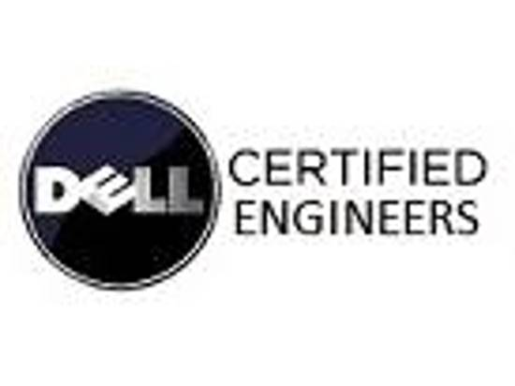
HCL INFOSYSTEM LTD
Dell Break-fix Engineer Jul’ 13 to Feb’14, Feb’ NETWORK & SYSTEM ADMINISTRATION PROFESSIONAL

System / Network Administration  Hardware & Software implementation & maintenance  Strategic Management & Leadership  Installation & Configuration  Technical Troubleshooting  Customer / Technical Support  Server Management  Security Concepts  Data maintenance  Backup & Recovery  Training  Cross-functional Coordination
- Dell Certified System & Network Administration Professional, offering experience of 7 years across Network Engineering, Server Implementation, Installation, Configuration, Technical and Functional Troubleshooting & Maintenance; currently spearheading as Dell Break-fix Engineer with HCL Infosystem Ltd
- An articulate professional with vast exposure across IT security management, installation and support of Windows 2000/XP and Win2003, Administration of Desktop, Laptops, Servers, Backup and Peripherals; acumen in Network Infrastructure like Hardware, Software, Ethernet Cabling, Ports, I P addresses.
- Possessing practical experience in Network set-up & Management, System Administration including Server Implementation & Administration, Disaster Recovery Management, Technology Support and Technical troubleshooting
- Possess thorough understanding of networking and security concepts pertaining to LAN, WAN, networking protocols & topologies, networking devices administration and maintenance, & Troubleshooting in multi-platform environment. Working knowledge of Domain, Active Directory and Domain Controller
- Proven ability in resource leveling, team building and team consensus, developing project scope, continuous design improvements and conducting status meetings; thrive in a deadline intensive environment, multi-task, perform under pressure, and meet deadlines. Achievement oriented, hardworking and dedicated with strong leadership skills
- Spearheading efforts as a Dell Certified System Engineer; responsible for handling Installation, Maintenance and troubleshooting of complex hardware and software and upgrades to ensure work is performed as per the company policy for OJT as Customer Engineer and for Oriental Insurance as a Residence Engineer across Karnal & Chandigarh Region.

CMC LIMITED-A TCS Company Aug’ 11 – Jul’ 13
Field Engineer & Technical Support Engineer

- Provided solutions for new & improvement of technical infrastructure to support business solutions functions; managed technology assessments and recommendations in support of Automation and Technology for Reliance Fresh Ltd & Punjab Excise Department - Provided consultation, advice and technical support to users regarding operational/applications
- Managing Configuration, Installation & Troubleshooting HPDl320, VSAT, Switch 2960, IDU, ODU, POS, Orbit Scanner, weight Scale, Thermal Printer, Zebra Printer & Laser Printer etc,.
- Looked after the network infrastructure LAN/WAN, installation, migration and configuration of network client workstations; addressed performance bottlenecks and ensured maximum network uptime.

HARYANA POLICE / IGP Jan’ 10 – Jul’ 11
Assistant Computer System Engineer

HCL INFOSYSTEM LTD Feb’09 – Nov’09
On-job –Training/Associate ESO DEPT

BHARAT HEAVY ELECTRICAL LTD Aug’ 07 – Jan’ 09
Diploma Trainee/Networking Engineer
EDUCATIONAL CREDENTIALS

Bachelor of Engineering (Computer Science & Engineering)
The Institution of Engineers (India) - Associate Membership Institute of Engineers (AMIE)

Diploma Computer Engineering; (3 Years)
State Board of Technical Education, Chandigarh

Certification
- ITIL v4 Certified (Information Technology and infrastructure Library )
- Generative AI Overview For Project Managers from PMI ( Project Management Institute)
- Project Management Fundamentals From IBM SkillsBuild
- Data Center Project Management Certification From Schneider University
- Diploma in Project Management for CPD Certification Service.UK
- ISO/IEC 27001:2022 Lead Auditor From MASTERMIND
- ISO/IEC 27001 INFORMATION SECURITY ASSOCATE From SkillFront
- ISO/IEC 22301-Business Continuity Management System (BCMS) From RISKPro
- Six Sigma Yellow Belt From VMEdu . Inc.
- Cyber Security Foundation Professional Certificate From CertiProf
- Array Certified ADC Professional
- Array Certified WAF Professional
- MCSE .Networking and Computer Hardware, Techno Mind Chandigarh
- Dell Certified System Engineer (34 Certification Laptops & Workstation), HCL & DELL Hyderabad
- E-SOP Certified from DDU-GKY

Technical Training
- PMP(Project Management Profession) Training Online
- ISO 27031-Information and Communication Technology (ICT)for business continuity
- IT-GA -SoX- Sarbanes-Oxley Act, U.S federal law for Prevent Financial fraud
- Hardware and Networking, Technical Support at Fusion Technology Pvt Ltd; 4 weeks
Date of Birth: 6th December, 1988
References: Available on requests

